

**Software Requirements Specification For**

**Team17**



**Version 1.0 approved**

**Prepared by**

Ishika Jethawa

Sejal Chotaliya

Daya Sarvaiya

Gautam Goklani

**Team 17**

**Index**

1. **Introduction**

1.1. Purpose

1.2. Document conventions

1.3. Intended audience and reading suggestions

1.4. Definitions

1.5. Project Scope

1.6. References

1. **Overall Product Description**

2.1. History

2.2. Product Perspective

2.3. Product Features

2.4. User Classes and Characteristics

2.5. Operating Environment

2.6. Design and Implementation Constraints

2.7. Assumptions and Dependencies

2.8. User Documentation

1. **Specific Requirements**

3.1. Functional Requirements

3.2. External interface requirements

3.3. Performance Requirements

3.4. Other Non-functional Requirements

3.5. Constraints

1. **Design**

4.1. Class Diagram

4.2. Flowchart for application

1. **Testing**

5.1 Black Box Testing

5.2 White Box Testing

1. **Wireframes**

**1. Introduction to Team17:**

**1.1. Purpose:**

The document describes the software requirements and specifications of Team17. It is an online application that allows users to put the request for product development to the digital agency named as mentioned. This agency will complete the work in the given time and then deploy/give the product to the user. This app can be installed from the Google play store or our website.

**1.2. Document Conventions:**

Text Formats:

Font: - Kokila (Body and Headings)

Font Size: - 12 for Body, 14 for Sub-headings, 16 for Headings

|  |  |
| --- | --- |
| **MNEMONICS** | **MEANING** |
| DB | Database |
| DDB | Distributed Database |
| DFD | Data Flow Diagram |
| ER | Entity Relationship |
| SS | Screenshot |

**1.3. Intended Audience and Reading Suggestions:**

The document is intended for all the developers - designers, coders, testers and maintainers.

The reader is assumed to have basic knowledge of Mobile OS, databases and user accounting along with knowledge and understanding of DFDs, Class Diagrams and Use-Case Diagrams.

**1.4. Definitions:**

**1.4.1. User Account:**

A user account is a location on a network server used to store a computer username, password, and other information. A user account allows or does not allow a user to connect to a network, another computer, or other share. Any network that has multiple users requires user accounts.

**1.4.2. Mobile Operating System:**

A mobile operating system, also called a mobile OS, is an operating system that is specifically designed to run on mobile devices such as mobile phones, smartphones, PDAs, tablet computers and other handheld devices.

**1.4.3. Database:**

A database is a collection of information that is organized so that it can easily be accessed, managed, and updated. In one view, databases can be classified according to types of content.

**1.4.4. Distributed Database:**

A distributed database is a database in which storage devices are not all attached to a common processing unit such as the CPU, and which is controlled by a distributed database management system together, sometimes called a distributed database system network.

**1.4.5. Data Flow Diagram:**

A data flow diagram (DFD) is a graphical representation of the "flow" of data through an information system, modeling its process aspects. A DFD is often used as a preliminary step to create an overview of the system, which can later be elaborated.

**1.4.6. Use Case Diagram:**

In software and systems engineering, a use case is a list of actions or event steps, typically defining the interactions between a role (known in the Unified Modeling Language as an actor) and a system, to achieve a goal. The actor can be a human or other external system.

**1.5. Project Scope:**

**“Experience the world in new ways, every day”**

Team17 is an online application that gives the user freedom to send product development requests. By using this application users can see the posts made and shared by the digital agency on their social media page. Users can also use the open-source products developed and shared by this agency.

This Product can be very useful for users to communicate with this agency remotely. This agency does everything from making designs for UI, developing systems to marketing that product. So, people don’t have to communicate with different agencies for different work. They can get their whole product with the help of this agency.

**1.6. References:**

Team17.epizy.com

Wikipedia.com

Slideshare.com

Figma.com

App.creately.com

**Overall Product Description:**

**2.1. History**

Initially Mr. Vivek Padia (CTO) and Mr. Dharam Bhojani (CEO) had done various analysis on the surveys of several companies working for its industry and through all the survey they found out that customer are being tired of going to in company to another so, at this moment team17 came into the picture. They decided to make a one stop availability for the new & young / youth entrepreneurs to make their business at high end. Also, to reduce the actual cost for the development as well as marketing their product to the real world. Also, to make the things in a really creative manner Team17 focuses on the quality product rather than a quantity product.

**2.2. Product Perspective**

Team17 is one of the most unique agencies which does everything from designing to development, advertisement. It is a one stop agency because of that you don’t need to contact many companies to do different jobs. And this agency focuses on quality products. These things make Team17 unique.

**2.3. Product Features**

**2.3.1. Friendly UI:**

This application will have an easy-to-understand interface as there are many applications in the market which are examples of complicated interfaces, because of which sometimes this type of applications can’t succeed. So, we decided to keep the application as simple as possible for users to understand as the clients are non-technical people so they can understand how to use this application easily.

**2.3.2. On time response:**

This feature is provided by Team17 as the client has to make requests for their product development through the application. Team17 will respond to client’s product request as soon as possible and as of them.

**2.3.3. QA Factor:**

There is a feature for asking questions from Team17 through the application. Because of this feature clients can ask questions at any time and they don’t have to visit them for their questions. They can ask for their product development status, to do changes in their product, canceling any changes in their product, etc.

**2.4. User Classes and Characteristics**

Some exemplary enhancement requests from users have been mentioned below:

**Notifications:**

Client has requested that he should be notified of whenever:

i. Admin tries to text him.

ii. He receives any message form team17.

iii. anything related to his profile.

iv. Some account action needs to be taken.

v. His account needs some security.

**Choose who can see:**

Our client also wants the liability to choose who can view his story and who cannot such that he can customize his setting whenever he wishes to and this setting should be bounded to one story and not all the stories following.

**2.5. Operating Environment**

The hardware, software and technology used should have following specifications:

* Ability to connect to the Wi-Fi or mobile network.
* Ability to exchange data over the network.
* Touch screen mobile phone
* Processor with speed of 512 MHz
* Continuous Power Supply
* Ability to take input from users.
* Device must have 2 GB of Ram or more
* Functional on android versions above 5.0 only.

**2.6. Design and Implementation Constraints**

* Create an account by entering email id, organization name, phone number and password.
* In case of network not available or user not able to exchange data over network, prompt error message “Connection not available”
* In case of not being able to access services of mobile hardware. Ex: camera is not working, prompt error message, “Can’t access camera”.
* Lock Account:
  + If the user failed to follow policies of our application.
  + In case of sending useless messages to Team17.
  + In case of asking for personal information through the QA factor.
  + Spamming through the project development request section.
  + The user account will be deleted.

**2.7. Assumptions and Dependencies**

* Network and data availability
* Power supply
* Better connection for exchanging information over the network
* Availability of mobile services.

**2.8. User Documentation**

For user manuals and help use the help option inside the application or <http://team17.epizy.com/> contact us for any other queries.

**3. Specific Requirements**

* **3.1 Function Requirements**

**FR1: Create Account**

**Description:** If user is new and want to create new account

**Input:** will request use for First name, Last Name, Email, Organization, Contact Number, password, Confirm password.

**Processing:** Retrieves the information and create a new Team17 Account for user

**Output:** Create and Display new Account For user

**FR2: Login to Account**

**Description:**  If user is Old and already have a Team17 Account

**Input:** Request for Username and Password

**Processing:** Retrieves the Required Information and Authenticate User

**Output:** Display Home Screen and welcome User

**FR3: Search**

**Description:**  Is user want to search a particular Product/Service/User

**Input:** Request a String referring about the searching piece

**Processing:** Will Receive the information provided and try to match data within Database

**Output:** Display Result if match Found otherwise Display: NO RESULTS FOUND

**FR4: Show Profile**

**Description:** If user wants to review his/her account Details

**Processing:** Will fetch the User information from the Data fetched during LOGIN phase

**Output:** Display user Data in formatted Manner

**FR5: ADD Post/Project**

**Description:**  If user wants to create/add a new Post/Project of their own

**Input:** Request user for... Related Images, links (if any), Title, Description

**Processing:** Review the entered information for vulnerabilities

**Output:** Create and Display Post/Project (if everything is correct)

**FR6 Post Suggestion/Report**

**Description:**  If user wants to inform about app/ content to the Developers

**Input:** Request for Message in Text format

**Processing:** Review the Message for vulnerabilities/SPAM

**Output:** Display” MESSAGE SENT"

**FR 7 Chat Description**

Users can send text messages. The latest releases of Team17 we also include ages ranging from 20 to infinity. Output: Recent conversations are displayed.

* **3.2. External interface requirements**

**3.2.1 USER INTERFACES**

Each part of the user interface intends to be as user friendly as Possible. The fonts and buttons used will be very fast and essay to load on app. The pages will be kept light in space so that it won’t take a long time for the page to load.

The starting page of the application will be the login page and if the user has no account that it will direct to create a new account after that home page will appear.

**3.2.2 HARDWARE INTERFACES**

The hardware should have following specifications:

• Ability to exchange data over network

• Touch screen for convenience

• Keypad (in case touchpad not available)

• Continuous power supply

• Ability to keep a track of all birthdates of each and every user and send them a cake, wishes and many more

• Ability to connect to network

• Ability to take input from user

• Ability to validate user

• Ability to show relevant ads

• Should be user friendly

**3.2.3. SOFTWARE INTERFACES**

The software interfaces are specific to the target other user's Team17 software systems. Team17 demands software like GPS, login, etc… on the following mobiles (environment):

1. iOS

2. Android

**3.3. PERFORMANCE REQUIREMENTS**

**3.3.1. SCALABILITY**

Team 17 should be able to provide instant messaging services to 1 million users at any given time.

**3.3.2. PERFORMANCE**

Application must be lightweight and must send messages instantly.

**3.3.3. SPEED**

Application’s processing speed should be so high that there should be no delay in executing the user's instructions. Also, the application should not crash repeatedly.

**3.3.4. CACHE MEMORY**

The app shall not consume more cache memory. Even if it does, it must provide a choice to the user to clear the app cache manually.

**3.3.5. ROBUSTNESS**

In case a user's device crashes, a backup of their chat history must be stored on remote database servers to enable recoverability.

**3.4. OTHER NON-FUNCTIONAL REQUIREMENTS**

**3.4.1. PRIVACY**

The users are provided with the benefit of customizing their privacy settings. Hence, they shall make the best use of these settings: Choose who can view your profile and so on.

**3.4.2. SECURITY AND SAFETY**

Keep your password safe and don't share it with any other people, applications, or websites under any circumstances. We also suggest using a different password for every service you use.

**3.4.3. RELIABILITY**

It is very important that the app is reliable as 2M+ users use Team17 simultaneously.

**3.4.4. PORTABILITY**

Team17 can be used on android phones and tablets.

**3.4.5. USER FRIENDLY**

This application is user-friendly, meaning to say even if one just installed the app and uses it for the first time, he’d find it easy to operate the application.

**3.4.6. MAINTAINABILITY**

Team17 is an app and hence has maintenance on loop. Team17 Beta releases all

new updates first and looks for acceptance from its customers. Team17 always surprises its

users by releasing fresh updates.

**3.4.7. SUPPORT**

A good software is one which listens to its customer’s feedback and helps them whenever they need something.

**3.4.8. PERMISSIONS**

The following permissions need to be granted in order to access all the features of the application:

**ANDROID PERMISSIONS:**

**1. Read phone status and identity:** Autofill your phone number when you register for Snapchat, for your convenience.

**2. Receive text messages (SMS):** Autofill the SMS code that Team17 sends you during phone number verification, for your convenience.

**3. Modify or delete the contents of your USB storage:** Save SS to your device's photo gallery, send photos in Chat, and more. Team17 also uses your device's storage to save settings and cache content you send and receive.

**4. Full network access:**

Send and receive SS, chats, and other data.

**5. Receive data from the internet:**

Receive chats, and other content from other chatters.

**6.View Network Connections:**

App optimizes chat, text and photos delivery based on the strength of your internet connection.

**7.Change network connectivity:**

Connect directly to Spectacles via Wi-Fi.

**8. Precise location (GPS and network-based**): Use your location for other services that improve your experience.

**3.4.9. BACKUP & RESTORE**

This feature is the most important. Today, we exchange devices like crazy and thus there’s no guarantee of us using the same device for forever. So our app provides a backup and automatic restore facility relating to the online cloud database which backs up all your data (upon giving your permission) and all the backed up information can be easily restored later.

**3.4.10. FEEDBACK/WRITE A REVIEW**

Once the app has been installed, the customer/user can write his valuable feedback. He can rate the app accordingly and can openly share his thoughts and always welcomes opinionated suggestions.

**3.5. CONSTRAINTS**

**Important constraints:**

1. Login id & password of user must be valid

2. Signup details – mandatory valid details must be provided by the user.

3. New accounts with existing account details cannot be created.

4. Internet availability

5. If the location of a user is located in unusual places within frequent intervals, verify the user's presence and use of the app.

6. OS required: Android (5.0 lollipop) mobile/tablet platform

7. User MUST AGREE to all terms & conditions laid by Team 17 lest he cannot use the application.

**4. DESIGN**

**4.1. Class Diagram**

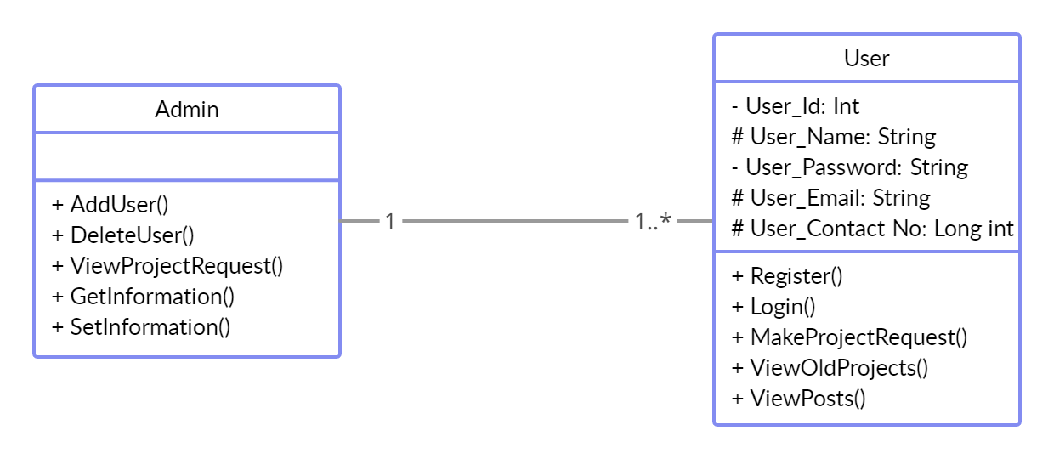

**4.2. Use Case Diagram**

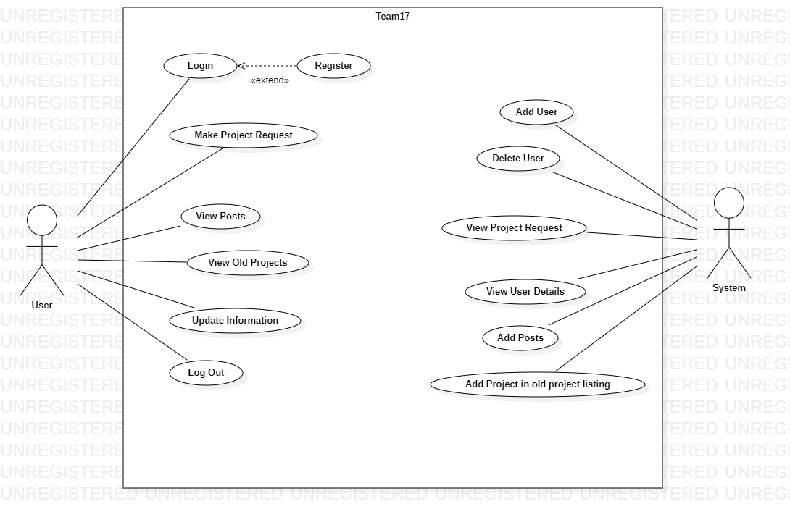

**4.1 Data Flow Diagrams**

**4.1.1. Context Diagram [Level –0]**

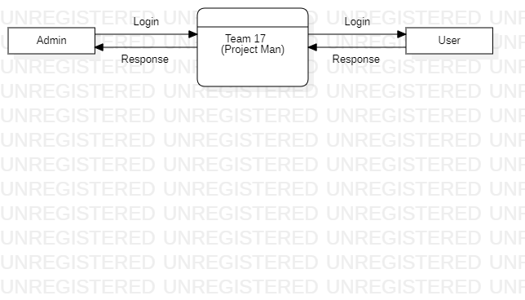

**4.1.2. Context Diagram [Level –1]**

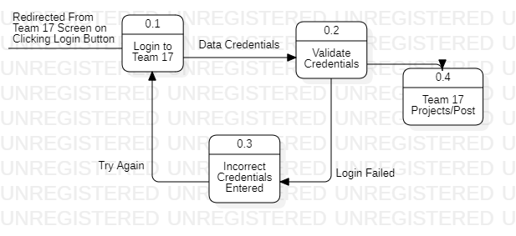

**4.1.3. Context Diagram [Level –2]**

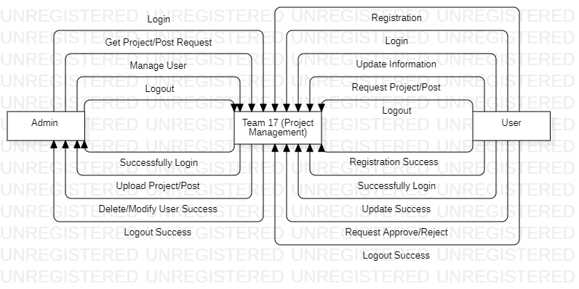

**WHAT IS ACTIVITY DIAGRAM?**

The activity diagram is another important behavioral diagram in [the UML](https://en.wikipedia.org/wiki/Unified_Modeling_Language) diagram to describe the dynamic aspects of the system. An activity diagram is essentially an advanced version of the flowchart that modeling the flow from one activity to another activity.

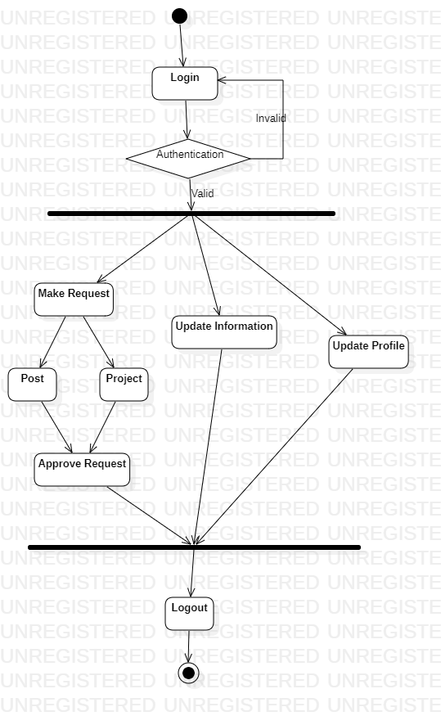

**Testing:**

**5.1 Black Box Testing:**

• Black-box testing is a method of software testing that examines the functionality of an application without peering into its internal structures or workings.

• This method of test can be applied virtually to every level of software testing: unit, integration, system and acceptance.

**5.2 White Box Testing:**

• White-box testing is a method of software testing that tests internal structures or workings of an application, as opposed to its functionality.

• In white-box testing an internal perspective of the system, as well as programming skills, are used to design test cases.

**Wireframes:**

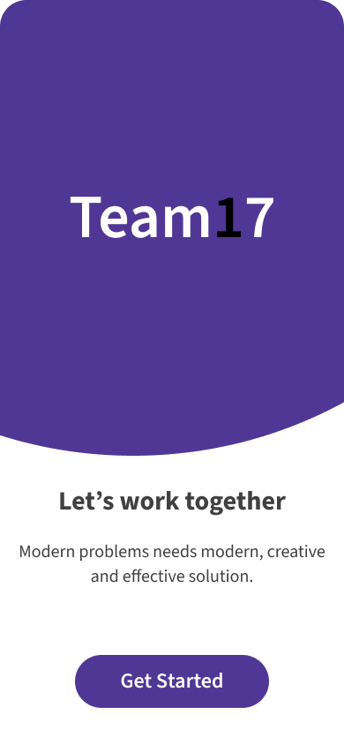

Fig. **Team17**

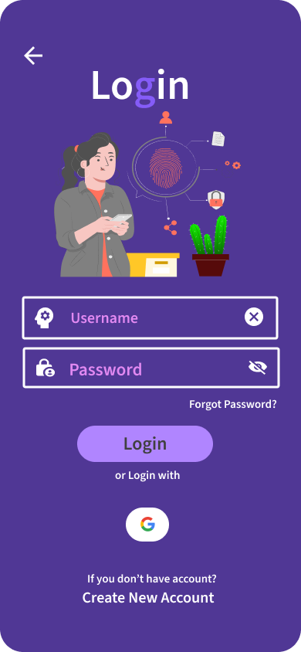

Fig**. Login Screen**

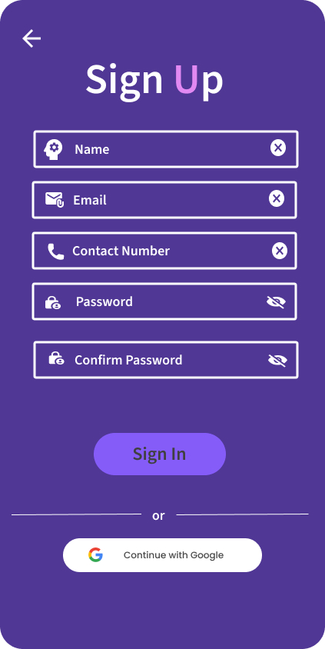

Fig. **Register Screen.**

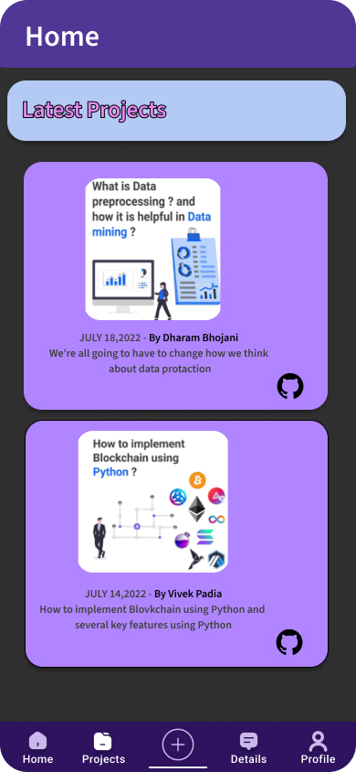

Fig**. Main Dashboard**

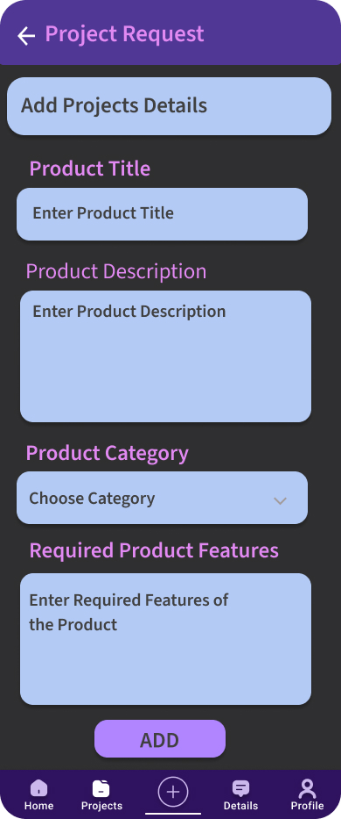

Fig. **Request for Project**

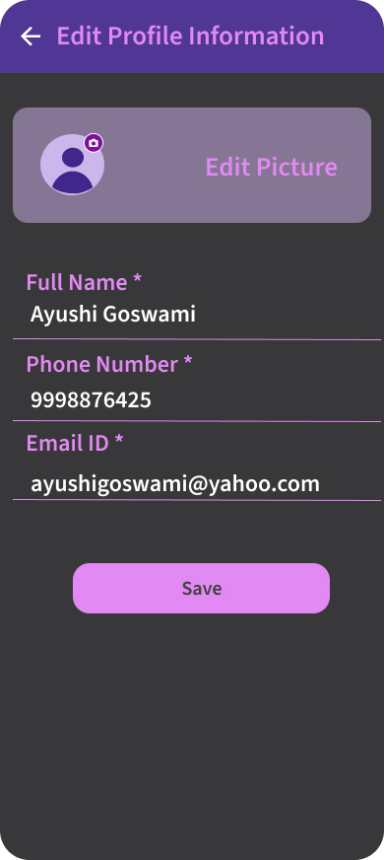

Fig. **Edit Profile**

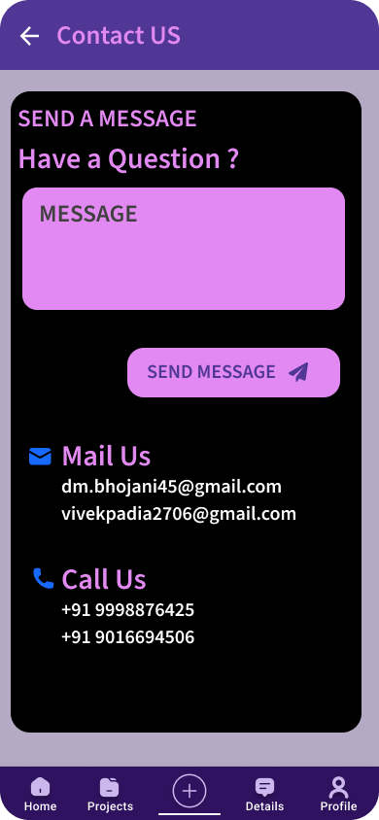

Fig. **Contact Us**

{**Note:** these wireframes are from prototype version: 1.2.4.36, the actual wireframe might have several differences in color or structure.}